Coupling

📌 Definition:
# Source: AI Source: Provided by: [Data Path: Persons Table -> ID Column: 1, Name_En Column: Motasem Essam] -> From: [Chatgpt (GPT‑5 Mini)] on [12/9/2025]
Coupling refers to the degree of dependency between classes or modules—how much one class relies on another.

🧠 Simple idea:
# Source: AI Source: Provided by: [Data Path: Persons Table -> ID Column: 1, Name_En Column: Motasem Essam] -> From: [Chatgpt (GPT‑5 Mini)] on [12/9/2025]
Coupling = “How connected classes are” 🔗

🔍 Key characteristics:
- 🔗 Measures interdependence between components
- ⚙️ Affects flexibility and maintainability
- 🧩 Can be tight (high) or loose (low)
- 🎯 Goal: keep coupling low

📊 Types of Coupling:

Based on overall dependency
# Source: AI Source: Provided by: [Data Path: Persons Table -> ID Column: 1, Name_En Column: Motasem Essam] -> From: [Chatgpt (GPT‑5 Mini)] on [12/9/2025]
• 🔴 Tight Coupling (High Coupling) → Classes/modules highly dependent on each other, changes in one affect the other
• 🟢 Loose Coupling (Low Coupling) → Classes/modules independent, changes in one have minimal effect on others

Based on degree/type of dependency (spectrum)
# Source: AI Source: Provided by: [Data Path: Persons Table -> ID Column: 1, Name_En Column: Motasem Essam] -> From: [Chatgpt (GPT‑5 Mini)] on [12/9/2025]
• 🔴 Content Coupling → One class directly uses internal details of another (very tight)
• 🔴 Common (Global) Coupling → Classes share global data, changes affect all
• 🟠 External Coupling → Classes depend on external modules (e.g., libraries)
• 🟠 Control Coupling → One class controls the flow of another by passing control info
• 🟡 Stamp / Data-Structure Coupling → Classes share composite data structures but only use parts
• 🟢 Data Coupling → Classes communicate using simple data (best/loosest)

🆚 Coupling vs Cohesion:
# Source: AI Source: Provided by: [Data Path: Persons Table -> ID Column: 1, Name_En Column: Motasem Essam] -> From: [Chatgpt (GPT‑5 Mini)] on [12/9/2025]
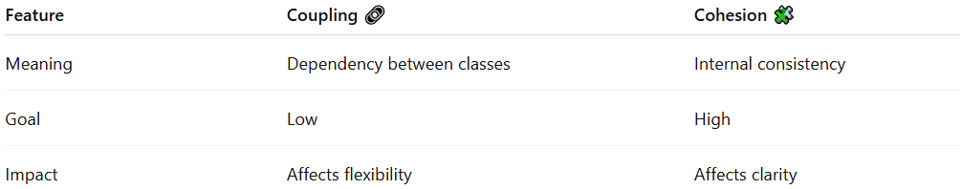
Feature | Coupling 🔗 | Cohesion 🧩
Meaning | Dependency between classes | Internal consistency
Goal | Low | High
Impact | Affects flexibility | Affects clarity

🎯 Why coupling is important:
# Source: AI Source: Provided by: [Data Path: Persons Table -> ID Column: 1, Name_En Column: Motasem Essam] -> From: [Chatgpt (GPT‑5 Mini)] on [12/9/2025]
- 🧠 Improves system design
- 🔄 Makes code easier to maintain
- 🧩 Enhances scalability
- ⚙️ Supports reusable components

🎯 Summary:
# Source: AI Source: Provided by: [Data Path: Persons Table -> ID Column: 1, Name_En Column: Motasem Essam] -> From: [Chatgpt (GPT‑5 Mini)] on [12/9/2025]
Coupling measures how dependent classes are on each other, and good design aims for low coupling to create flexible and maintainable systems.

